

T R A N S P O R T A T I O N M A N A G E M E N T S Y S T E M ( T M S )



SAVE MONEY, SHIP BETTER.

Freight quotes from hundreds of the top national and regional carriers are just a click away.

OLD

OAST LO ISTICS

(714) 576-6948 | CS@GCLFREIGHT.COM

LESS THAN



Let us help you reduce shipping costs and increase efficiency.

TRUCKLOAD (LTL)

Our services include:

-Instant pricing with hundreds of carriers

-One tool that lets you quote, book and track your freight 24/7

-Instant Pick up numbers

-Live Tracking Updates

-Liability and Full Coverage Insurance

-Flexible credit and net terms

-One company for all your shipping needs

-Dedicated Account Service team

D A S H B O A R D

Q u o t e s - S h i p m e n t s - R e p o r t s - A d d r e s s e s

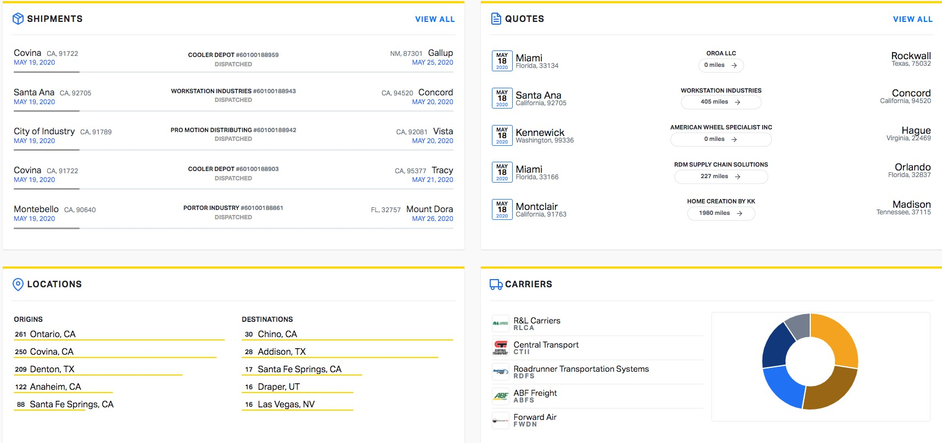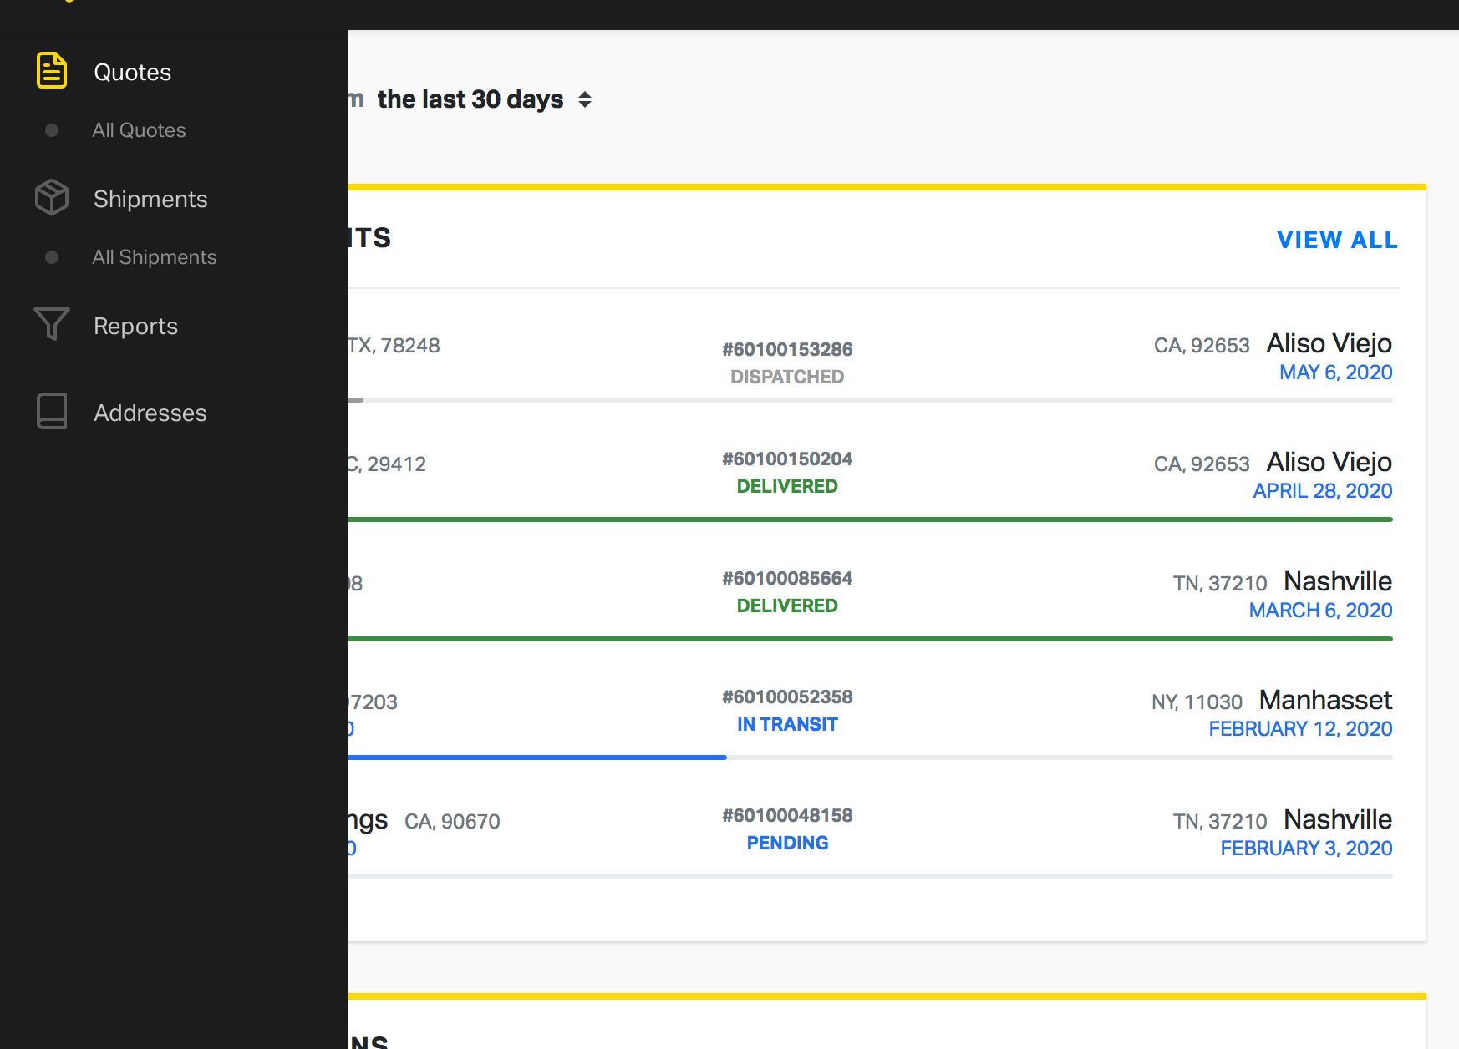

Freight Quote

Quote

# New Quote

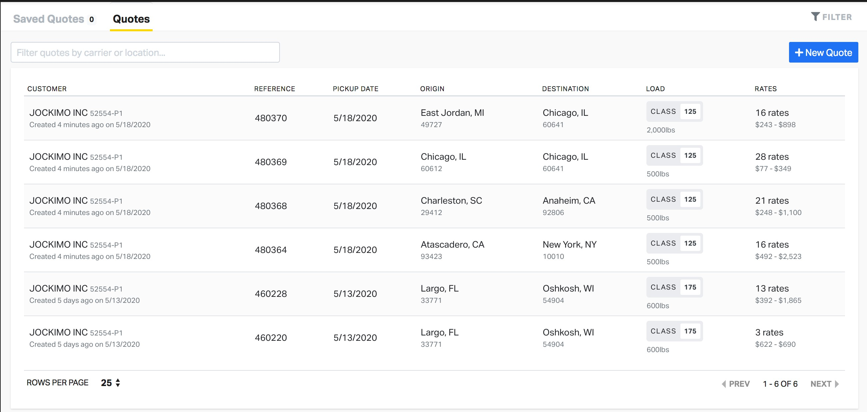

## NEW QUOTE

Click the blue Icon at the top right corner.

## SAVE QUOTE

Every quote Is saved and assigned a quote number

## CREATE SHIPMENT

Quickly search saved quotes and book the shipment

Key:

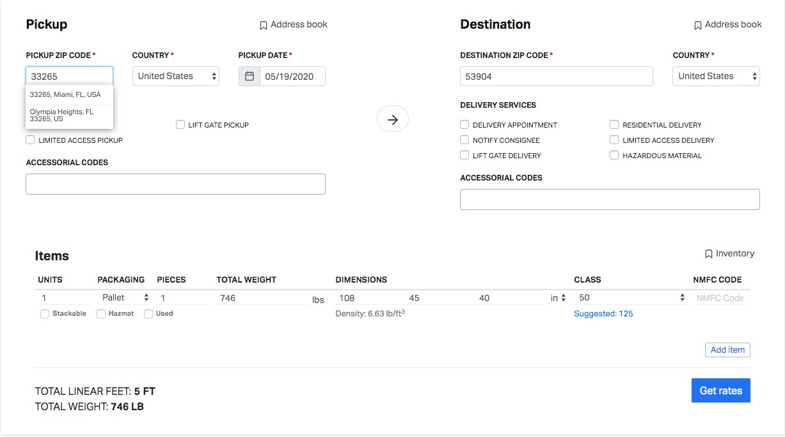

1

5

2

4

8

3

6

7

1. **Origin & Destination** - Make sure the zip code is correct and select the correct city. (the same zip code can be used for multiple cities)
2. **Shipment Details** - Pallet count, dimensions, weight
3. **Freight Class** - If you do not know your freight class, you can go with the suggested class or ask the GC team.
4. **NMFC** - National Motor Freight Classification - You need to make sure you are using the accurate information when booking shipments.
5. **Accessorial Options** - all shipments are assumed business to business with no additional services. If It Is not going to a business with a dock door, make sure you are Including the services needed at time of delivery - delivery apt, limited access, lift gate, inside delivery, etc.
6. **Add Item** - If you need to add additional units, please click "add Item"
7. **Linear Feet** - Amount of space taken up on a trailer. Anything over 12 linear feet, you need to email your rep for a rate.
8. **Density** - low density, high class. High density, low class. This number should be used for finding proper class and NMFC

###### Quote Number Carrier Search Options

*Your quotes will automatically be saved. You can use this reference number to look up and book the shipment later.*

*Sort by rate, low to high Sort by transit days*

*Sort by carrier liability, high to low*

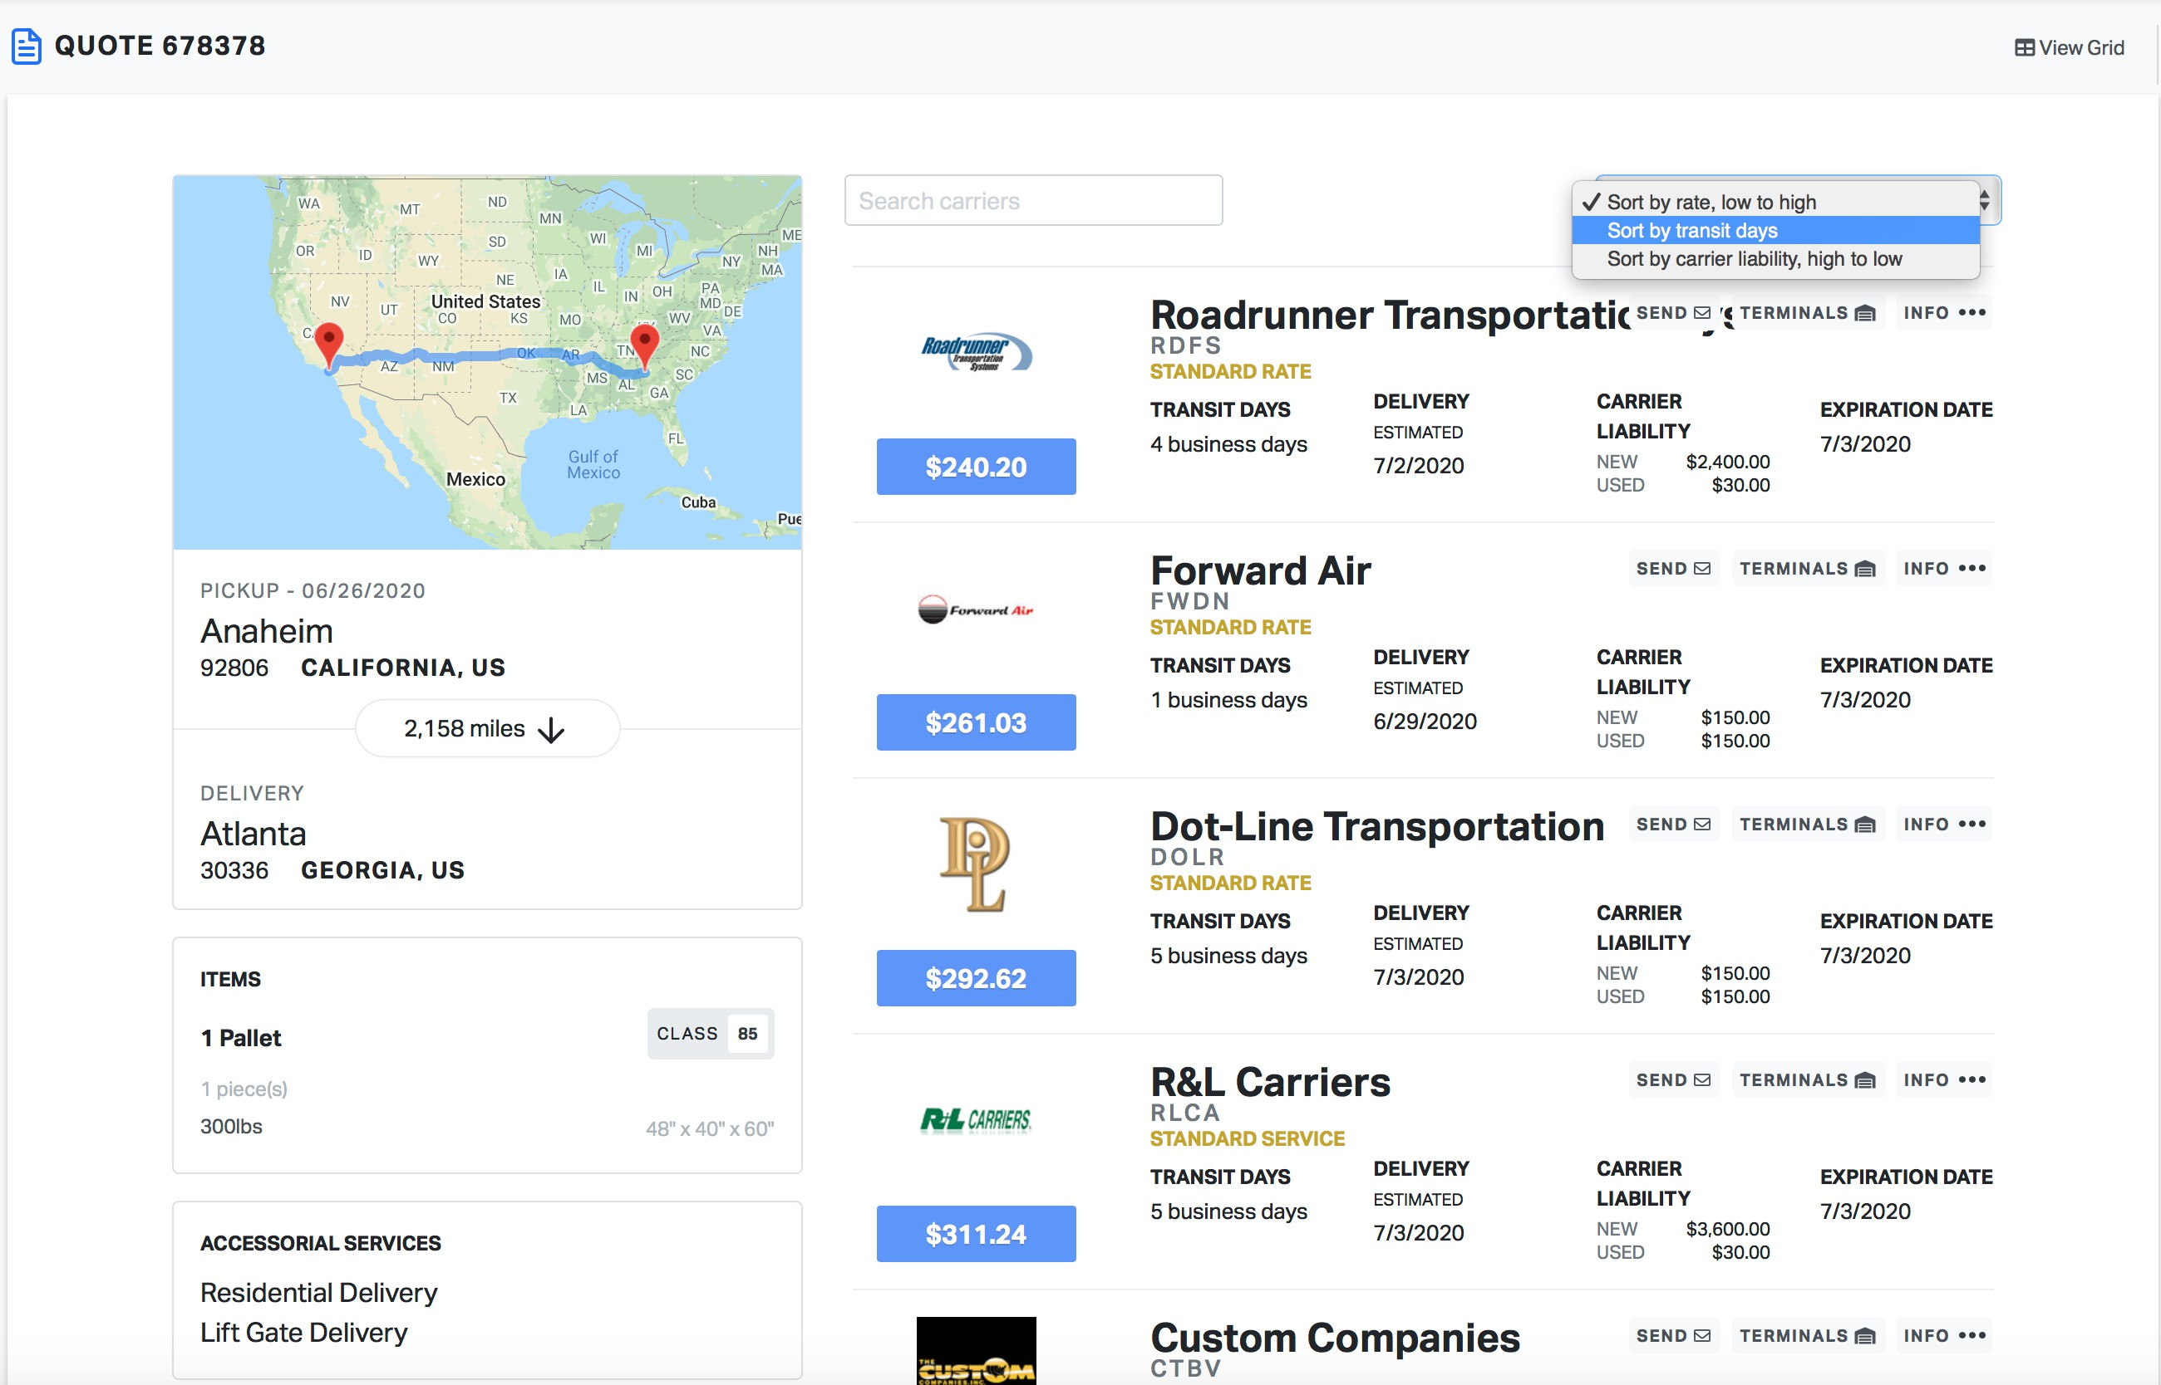

###### Carrier Liability

*Every carrier will have a maximum liability coverage for new and used goods. If your product is worth more than the amount covered, it is recommended to purchase cargo insurance.*

# Terminal

**Tools & Resources**

S A V E T I M E B Y K N O W I N G H O W T O U T I L I Z E O U R W E B S I T E

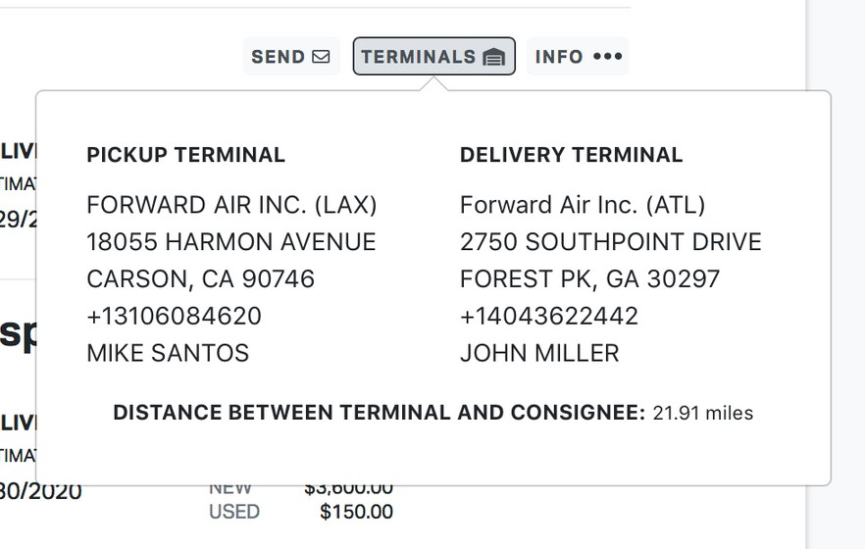This can be used for finding the address for will call pick up or dropping off freight at the terminal.

# Info

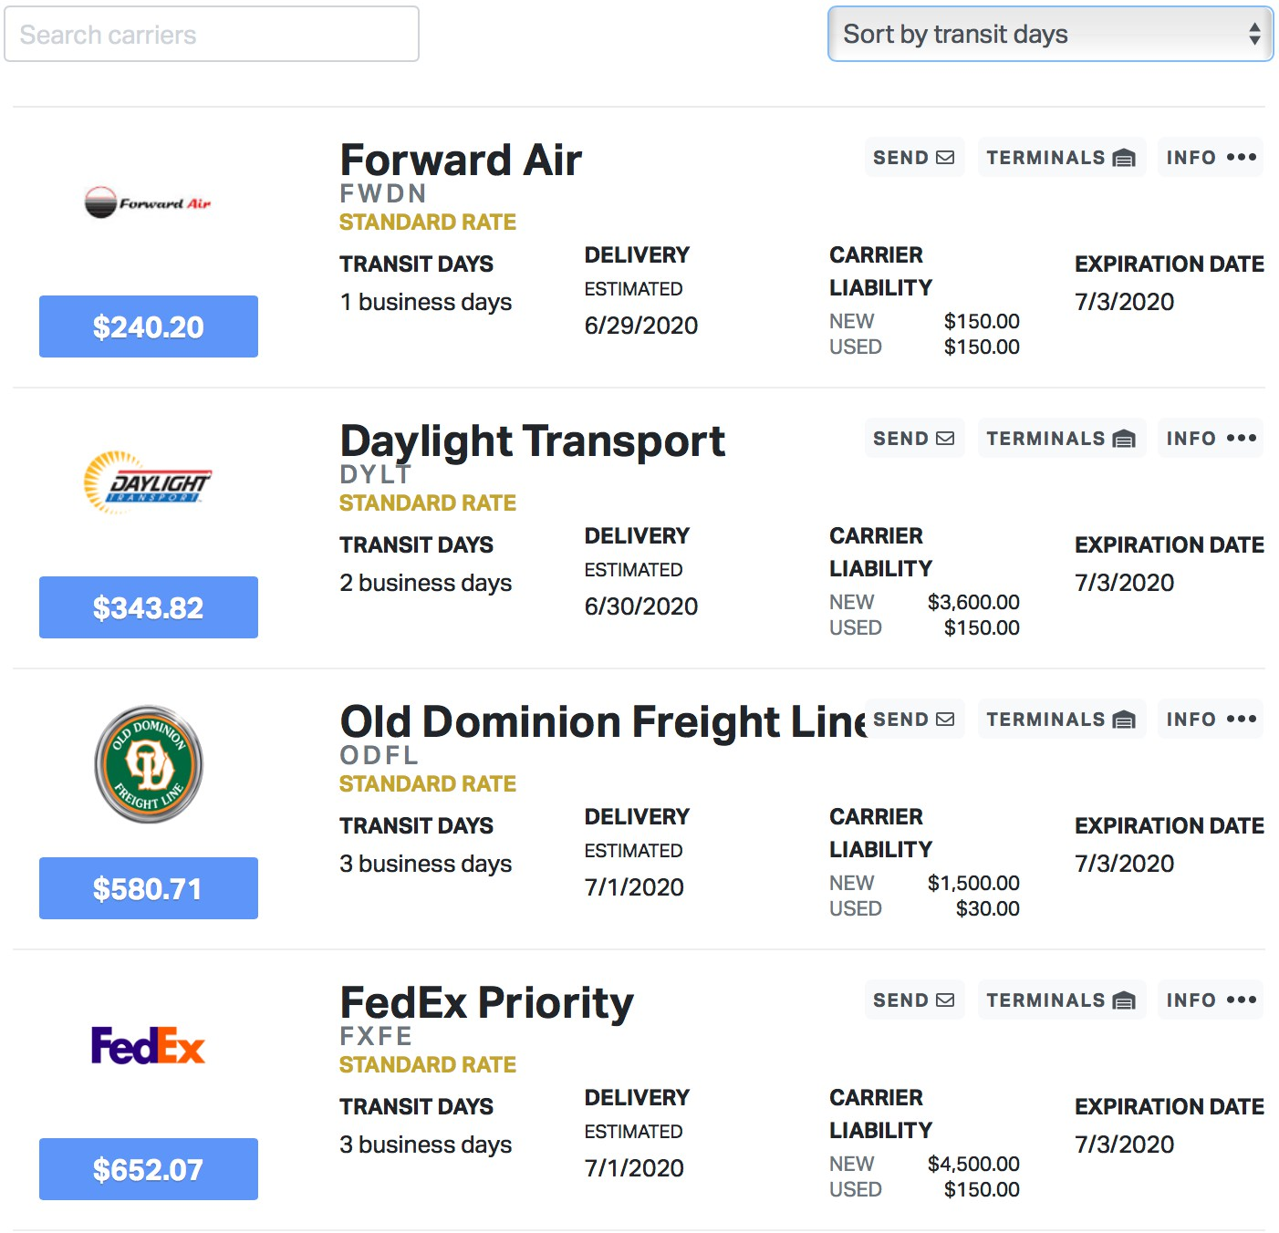

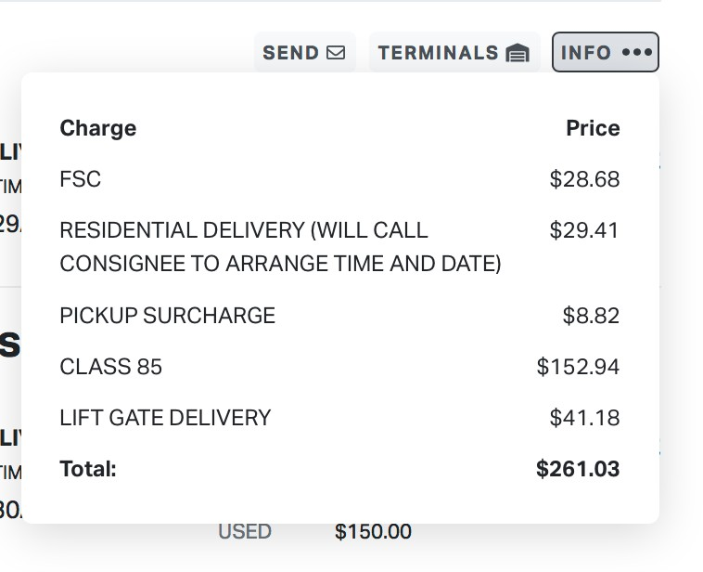

Rate Details - breakdown of the carrier charges. Some verbiage may be unfamiliar, but the total rate Is your "ALL IN" price.

# Expiration Date

If your quote expires, it will not allow you to book the shipment. In that case, you will need to click edit at the bottom left corner and re quote the shipment out.

Pickup & Delivery

The more details, the better!

Create your BOL

S E T T H E P I C K U P D A T E & T I M E

A D D S H I P P E R A N D C O N S I G N E E D E T A I L S I N C L U D E A S M U C H D E T A I L A S P O S S I B L E

C L I C K " S A V E T O A D D R E S S B O O K " F O R C O M M O N L A N E S W H E N C O M P L E T E D , C L I C K " S A V E & C O N T I N U E "

### Notes & Special Instructions:

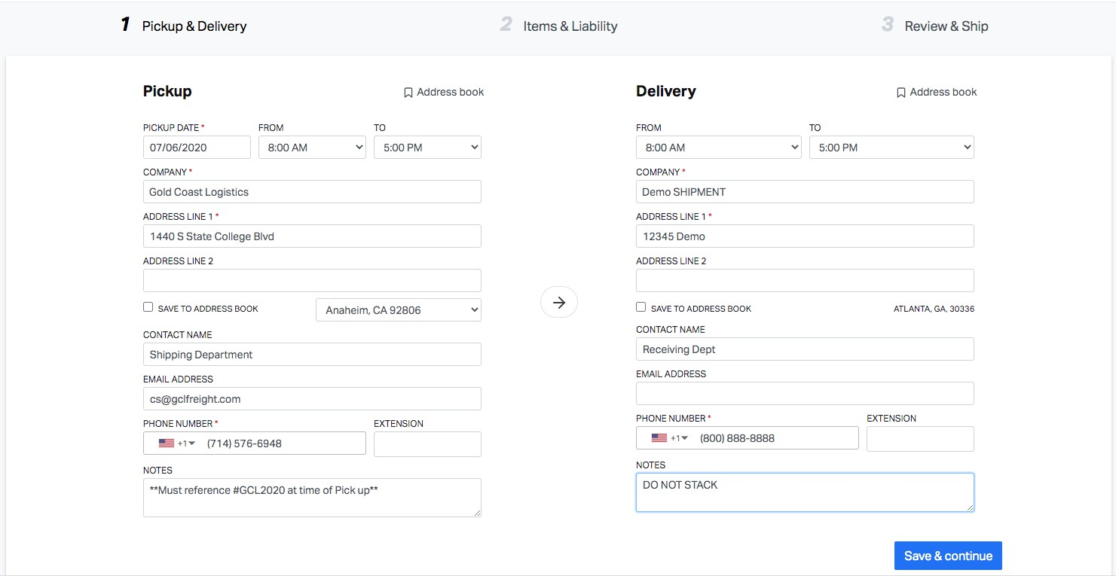

Give detailed Instructions for pick up and delivery to make sure everything goes smoothly. If you want something shown on every shipment (example; Do Not Stack), please let us know so we can set that up automatically.

Items & Liability

Knowing > Assuming

NMFC & Class Determined by Four Factors:

1. Density
2. Freight Stowability
3. Liability
4. Ease of Handling

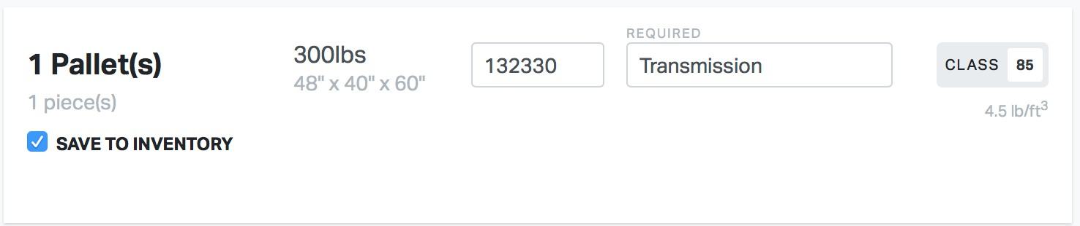

##### Liability Coverage

Liability for LTL shipments vary on a carrier- by-carrier basis, and the maximum liability can be up to $25 per pound for new goods, but can be subject to lower amounts depending on the carrier, packaging, freight class or other conditions.

##### Cargo Insurance

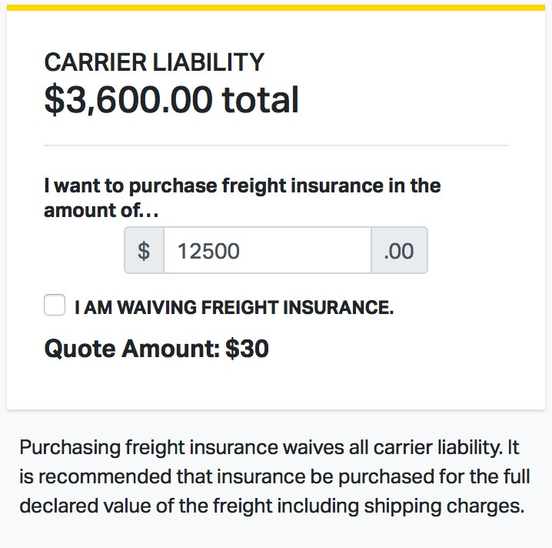Freight Insurance is a third party coverage beyond the standard carrier liability. For as little as $30.00 you can fully insure your shipment.

Review & Ship

Double Check Your Work

*Add automated notifications to help reduce time tracking shipments.*

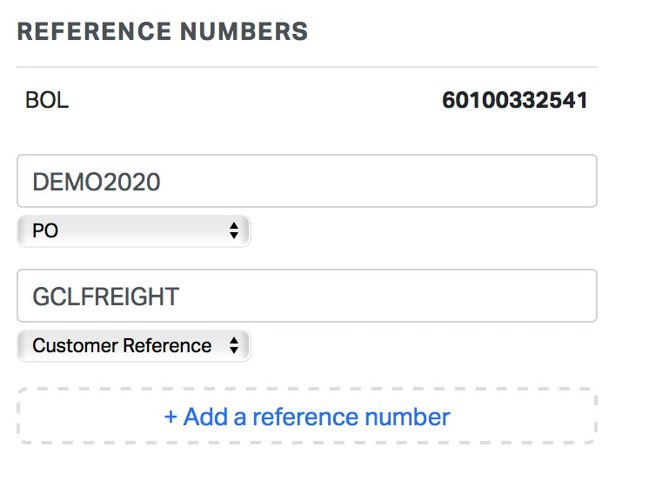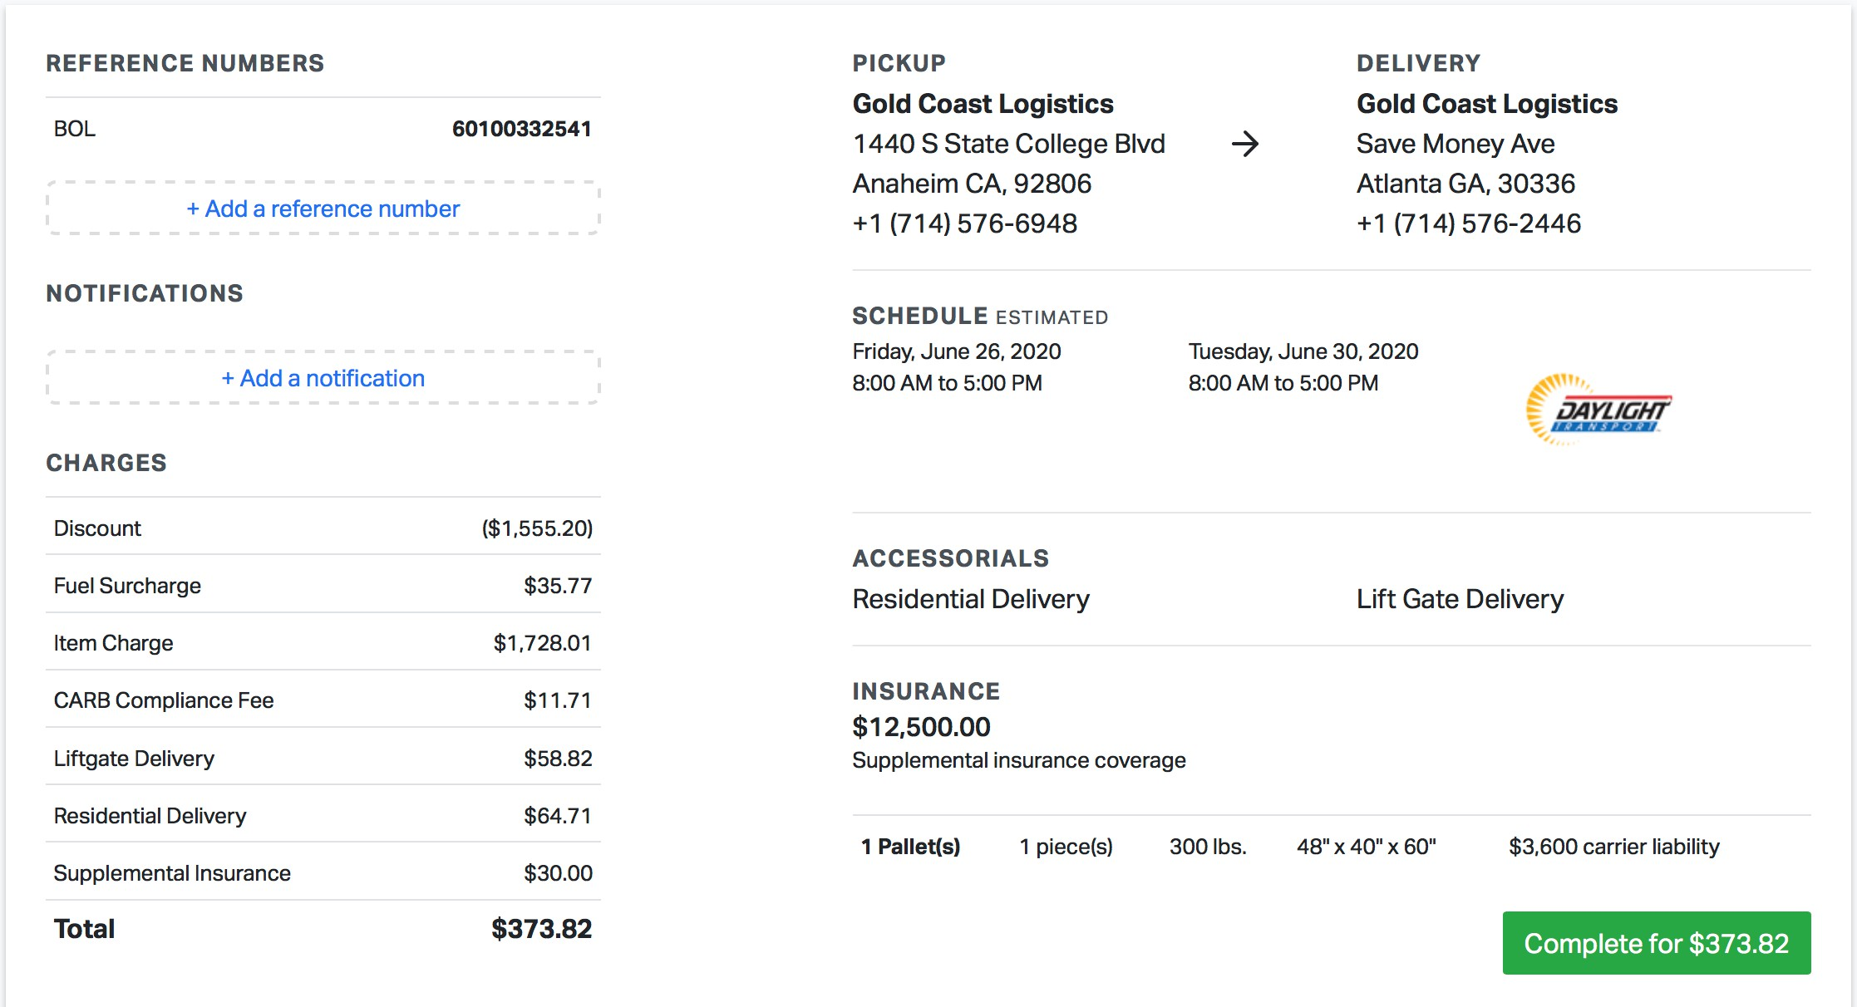

*Add reference numbers to any shipment to Improve accounting efficiency.*

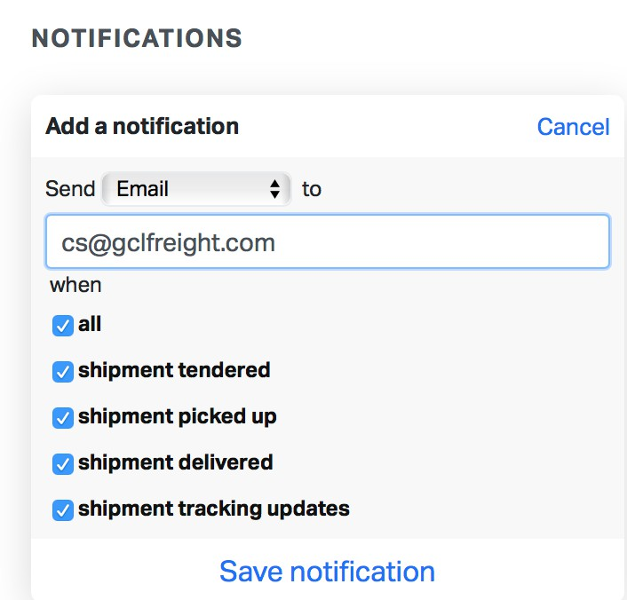

### Details - Load - Charges - Tracking - Documents

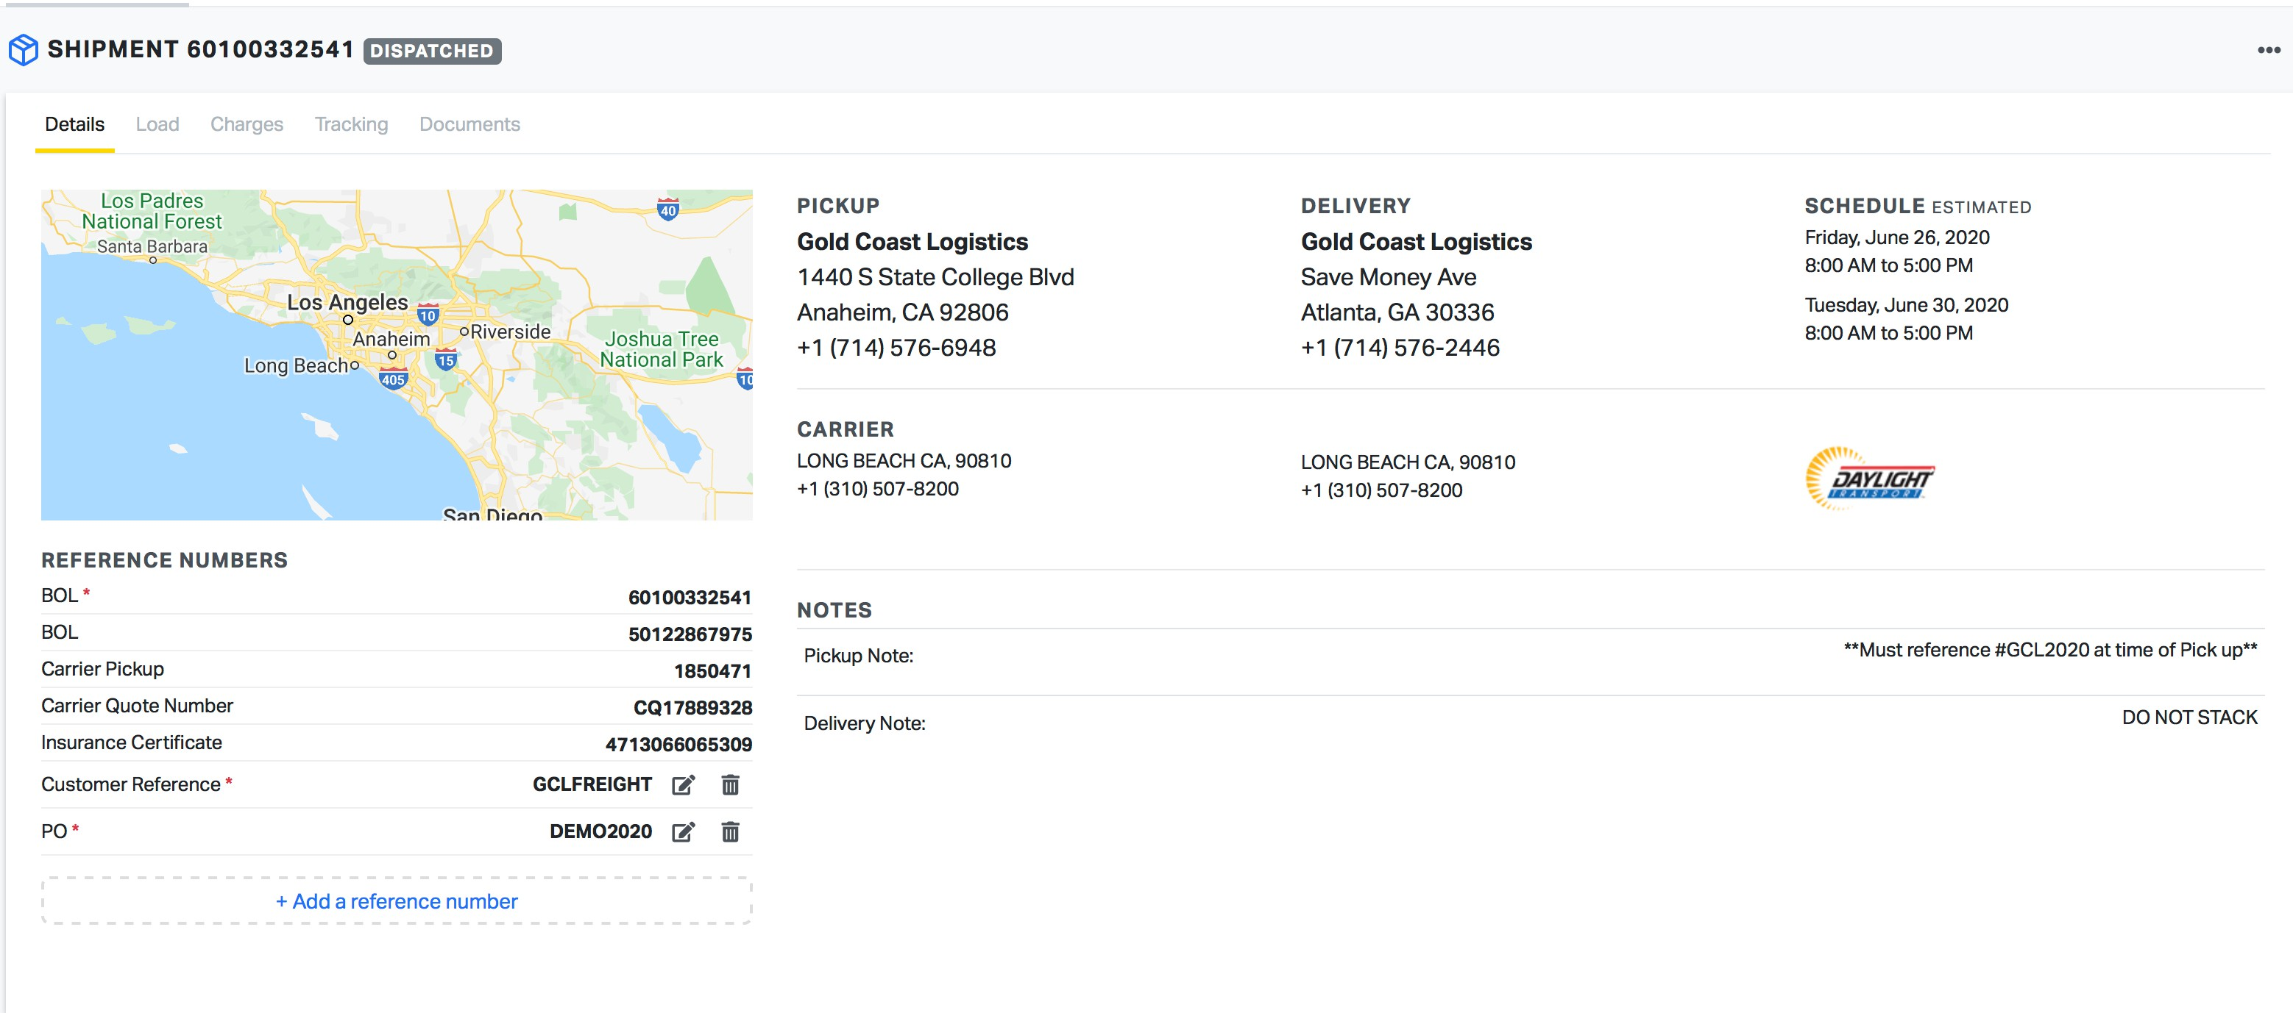

Managing your shipping has never been easier. You can easily toggle between the tabs to find details about the shipment, check the charges, track your shipments and print or email documents.

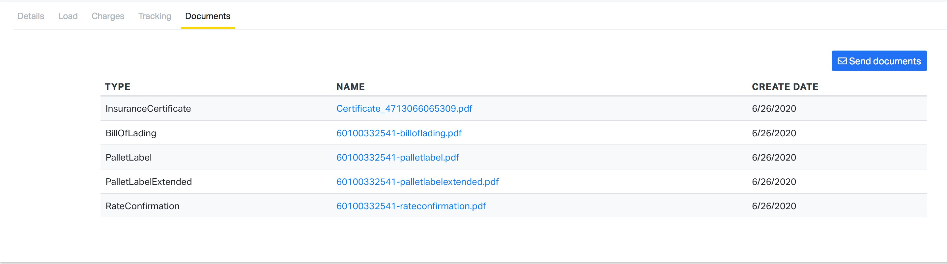

ERRORS

#### Freight Class

TRAINING 101

a. NMFTA updates the freight class and codes regularly. Using the correct class and NMFC can be the most difficult part of shipping and very expensive if done incorrectly.

#### Limited Access

* 1. This fee will be charged by the freight carrier for the following locations: construction sites, fairs and carnivals, military bases/installations, mine sites, prisons, schools or universities, churches, storage facilities, piers, airports, farm or ranches, campgrounds, zoos, reservations, government facilities, hotels/motels, casinos or resorts, hospitals, doctor’s offices, small strip malls, rural areas, or any location that requires a smaller or specialized truck, etc.

#### Liability Coverage vs Cargo Insurance

* 1. Assuming that the shipment is fully covered is common for new shippers. When booking shipments, It is essential to look at the liability coverage to make sure you are aware of the maximum value your shipment is covered. If you need additional coverage, make sure to book cargo Insurance for the full Invoice value, Including shipping charges.

#### Additional Charges

* 1. Whoever arranges the freight Is responsible for any additional services. It Is Imperative you explain this to your vendor or customer what Is Included with the shipment. If they need a lift gate, Inside delivery, sort & seg, lumper services, or any other services, make sure It is Included In your quote so that you are not suprised by a higher Invoice.

#### Expectations

* 1. Understanding the service you are using and the carriers reliability Is Important In setting proper expectations for your company and your customer. With some of the less expensive carriers, you should expect more delays In transit.

#### Claims

* 1. Concealed Damage
  2. Customer Responsibility